Sol Roth

**Releases new Rap SINGLE…** ‘The Riddler’s Last Riddle’  
*“A comic book themed energetic, aggressive rap song. The first song in a 22 song collection   
recorded in 22 days using only an iphone “*

[***LISTEN HERE***](https://open.spotify.com/album/4DzuSUdrwJTcYmXTbk3Al2) [](https://open.spotify.com/album/4DzuSUdrwJTcYmXTbk3Al2)[](https://music.youtube.com/watch?v=6g0oo3L79d0)[](https://drive.google.com/file/d/15_blB8Zy8DOJe0GYCUFizROt6nw4yAH-/view?usp=sharing)

FFO: DAX, GAWNE, ATLUS, EMINEM,

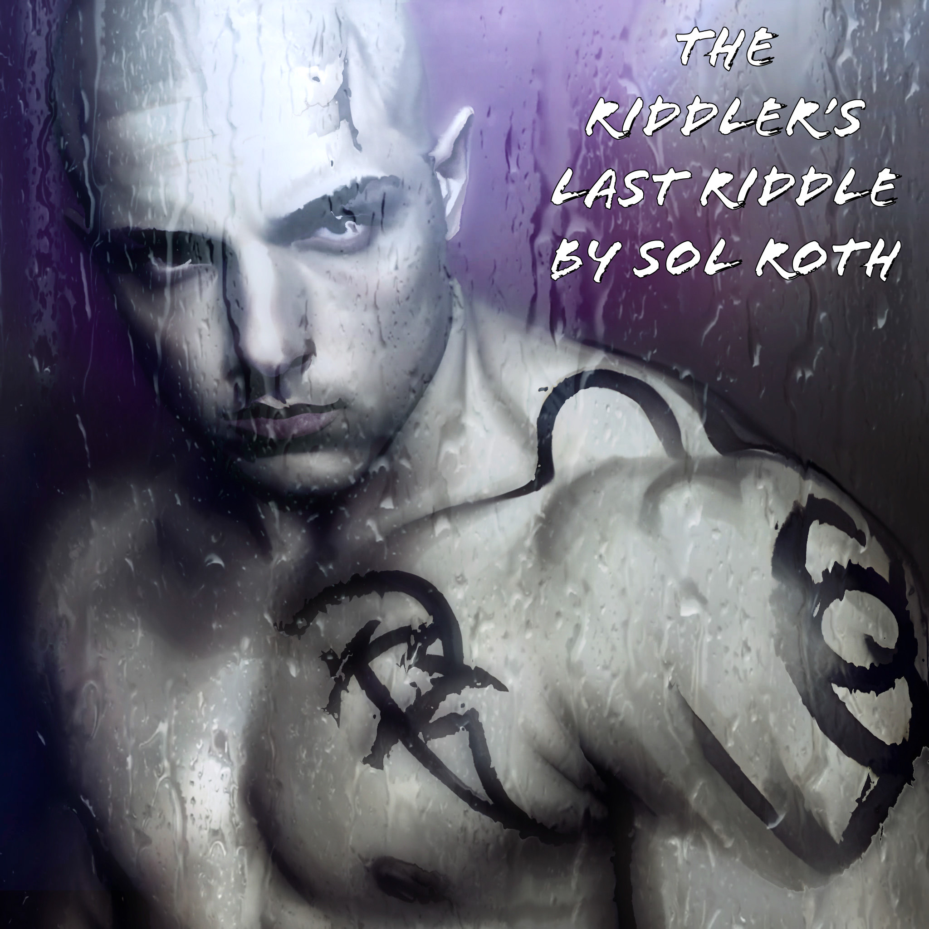

[**Press Assets Here**](https://drive.google.com/drive/folders/1k_CBN4_J_cVbkxveVU_iGBhYcs8dopdK)

_________

“Top Trending Track” - **Starmony | Listed on hundreds of Spotify Playlists**

*“We admire the scope…and all you were able to accomplish...your lyricism and vocal performance are the strongest…”* - **Alchemical Records**

“The Riddler’s Last Riddle” is an energetic, aggressive rap song with a comic book theme and philosophical underpinning. In what has been described as an insane burst of raw authentic creativity, it was one of 22 songs Sol Roth wrote and recorded in just 22 days, many (this one included) completed in a single 2 hour session using ONLY the smartphone app Starmony.

“I've always loved artists who can make you follow a story or theme in a piece of work that requires thought to unravel what the meaning is, while still being enjoyable on the surface. The levels of meaning are like a puzzle that listeners have to unravel. The farther they go down the rabbit hole, the more they can relate it back to their own lives, experiences and philosophy. During my recording experiment, where I made an entire song in 2 hours, I looked at some artwork on my phone, including the piece that became my cover art (of me as a new Batman villain), and I ran with it.” said Sol Roth.

Sol Roth is an LA based actor, artist and athlete. In his youth he played drums and sang vocals in various pop punk / rock garage bands. None of them got to the point of releasing albums. Fast forward some years, Sol Roth continued to develop his passion for music, writing songs and rapping, but previous to this, had not shared them with the world yet. Then one day, while reading about new recording technologies and apps (like Starmony) he had a life changing moment, where he realized that he already had the tools to create and release music and it was time to do EXACTLY that. And just like that, he started creating and creating and creating.

“Although I share a lot of myself as an artist, music was not usually included. It was one of the last things for me to release. I used to create music in my head, sometimes I’d write it down and make a basic recording, but nothing ever was released, so no one got to hear it. Then one day it was time to let them out and once the box was open, it’ll be shut again. I can’t wait to share all this music with the world.” - Sol Roth.

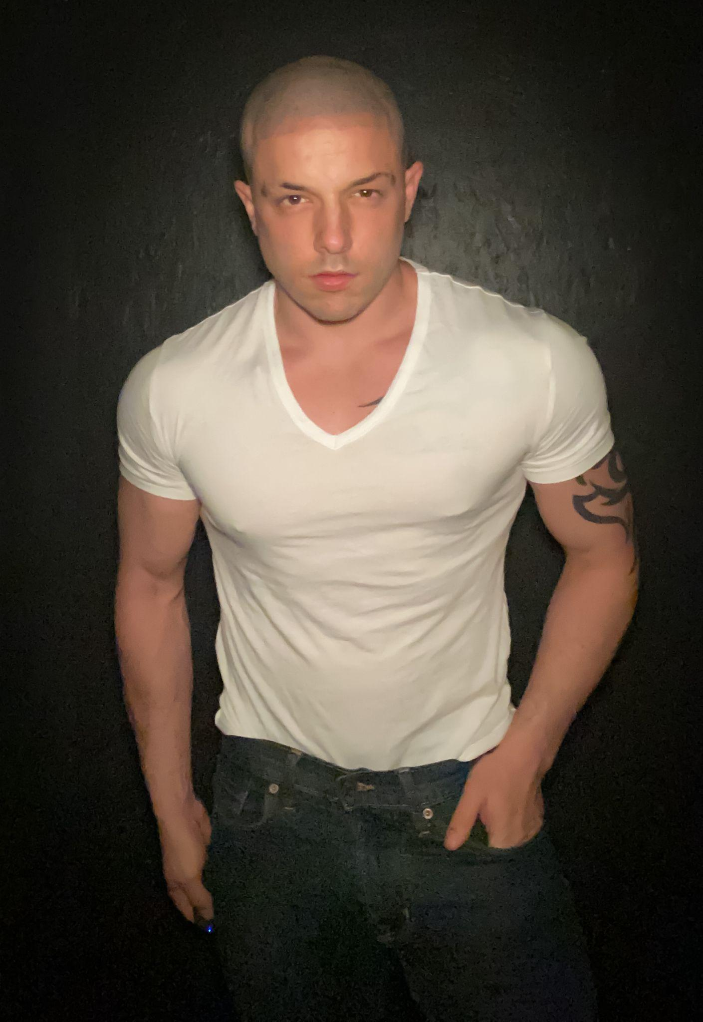

**FOLLOW Sol Roth -** [**www.solroth.com**](http://www.solroth.com)

|  |  |  |  |  |  |
| --- | --- | --- | --- | --- | --- |
|  | [@solroth01](https://www.instagram.com/solroth01/) | [@solro](https://twitter.com/solro) | [@solroh01](https://www.tiktok.com/@solroth01) | [/SolRothActor](https://www.facebook.com/SolRothActor/) | [/c/solroth](https://www.youtube.com/c/solroth) |

Email [solroth@solrothmedia.com](mailto:solroth@solrothmedia.com) for more information.